(Approx. 649 words)
CES 2019
By George Harding
Tucson Computer Society
January 21, 2019

There were 180,000 attendees, 4500 vendors and some 500 qualified press.

Press events: Unveiled (150 vendors), Digital Experience (250 vendors), ShowStoppers (200 vendors), press conferences all day Monday.

Notable items: More IoT and AI, plus 5G, 4K and OLED, autonomous cars, VR and AR
(VR means "Virtual Reality". AR means "Augmented Reality.)
The Internet of Things (IoT) is several years old now and has been used to allow operation of one or more devices remotely with one controller, usually a smartphone. Ex., lights, thermostat, garage door, etc.
Now IoT has been widely expanded to allow remote control of all devices with one controller. The goal appears to be to hook everything to everything else.

Artificial Intelligence (AI) is the use of computer programs to decide to take specific actions when defined circumstances occur, i.e. to cause apparently intelligent actions
One device that is a combination of AI and IoT is Footloose, a cat waste disposal device. But it’s more than that. It also analyzes the waste to identify possible illness, dispose of the waste hygienically, checks cat’s weight how often it uses the device, how long it spends there and how much it leaves behind. It can identify multiple cats (if you have more than one). It’s also self-cleaning and odorless, using NASA technology. There’s also a smartphone app.

Another example is a food-ordering system, perhaps set up in a public place, like an apartment lobby. You select your choices and the food is delivered into your cubicle. Again, a smartphone app is part of the system.
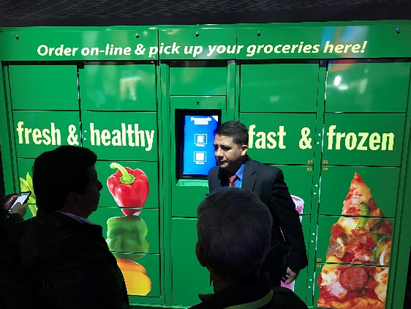
AI has tremendous potential and has already been used by many companies to speed up business operations.

The 60 Minutes program last Sunday talked with a Chinese entrepreneur investing in AI startups. They have 140 of them so far, 10 being worth $1 billion already. He says “Intelligence” is a misnomer, since these programs cannot think like a human and will never be able to do what humans can do.

5G is the latest generation of cellular mobile communications. It brings higher data rates, lower latency, higher system capacity and massive device connectivity (per Wikipedia). It is expected to allow much faster cellphone service, and much broader coverage. AT&T, Sprint and Verizon have already demonstrated 5G in limited locations. General availability is expected in 2020.
TV innovation is slowing, leading to ubiquitous inclusion of 4K and OLED. There is 8K on the horizon, but little is the way of source material.
Organic Light Emitting Diode (OLED) is created with a film of organic compound that emits light in response to electric current. This technology provides excellent color response, referred to as HDR, with blacker blacks and whiter whites. It also provides a much thinner TV unit, typically 3/4ths of an inch thick.

As usual, there were many car makers with their concept models. Autonomy is getting more widespread and the devices are being incorporated into the design, rather than strapped on top and side.
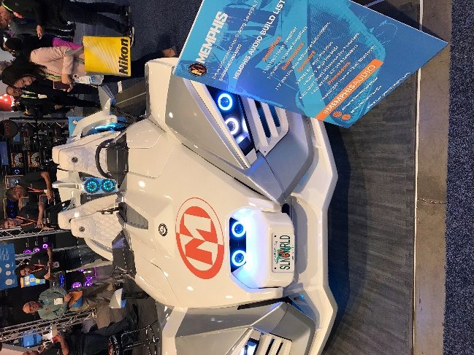
There was an autonomous VTOL helicopter from Bell.
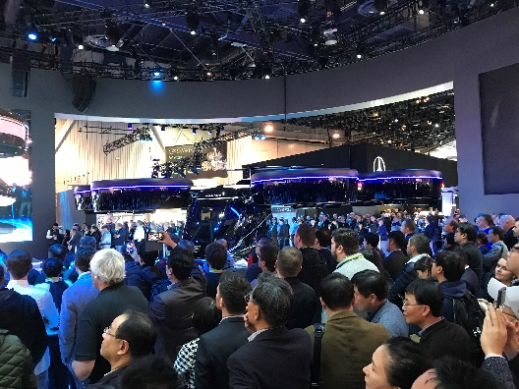

Hyundai Elevate helps first responders access very difficult areas.
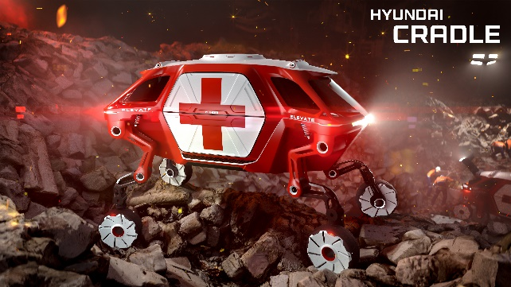
See video at https://youtu.be/A33Yu-9rgxo

Drones continue to increase in ability and decrease in price. DJI is the leader in the industry currently. Their lowest price drones are Mavic and Spark
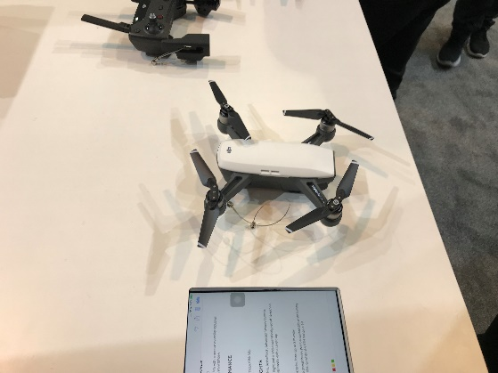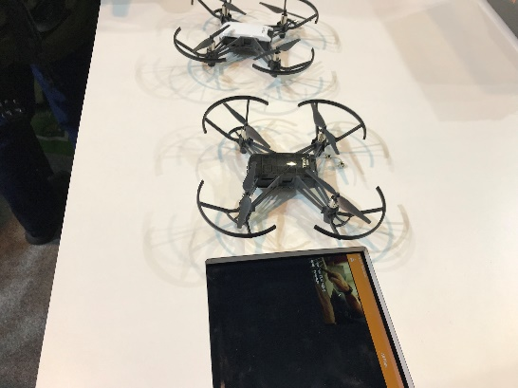
The rotors of the Mavic fold inward, making a very compact device to carry.

The increased speed of computer chips and the sophistication of devices has made VR more widespread, being used in companies for training, repair and more. AR is still not widespread.

Kodak showed a very small, compact projector, Luma, which can project to an 8-foot screen.
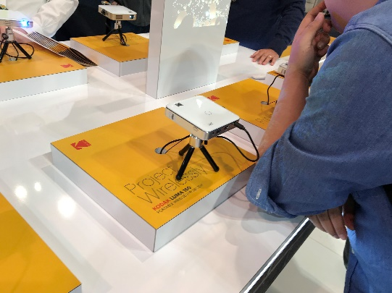

All in all, CES is a mammoth event that shows what is being provided today and will be provided tomorrow by companies that serve the consumer market.

CES is presented in early January each year. See their web site at www.ces.tech

